**Game Creek Rosette Hunt**

**Monday June 9th, 2025 (8:30 - 11:00)**

[**Register for this event here!**](https://docs.google.com/forms/d/e/1FAIpQLSeIgoFtVQIVLcAm-Y0OoEzmWO0Q0T5wwIYoHrCNzraHFvzFCg/viewform?usp=sharing)

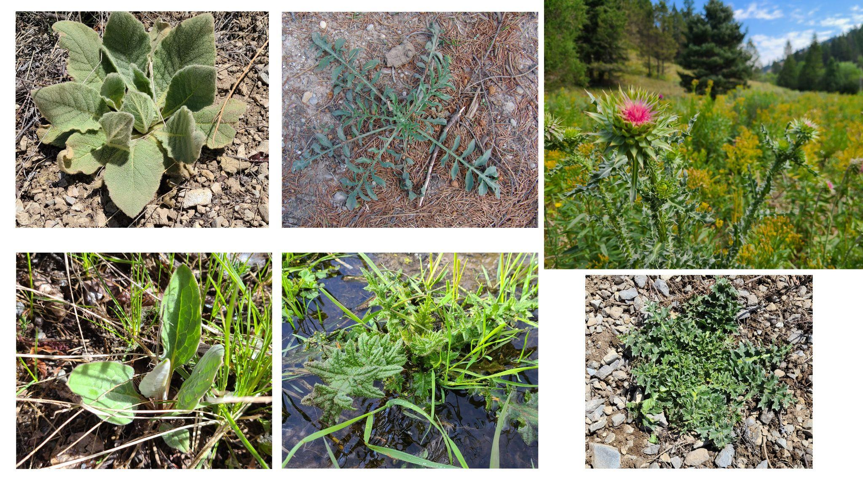

**Site Overview**: Game Creek Trailhead, located 9 miles south of Jackson, is a beloved access point into the Bridger-Teton National Forest. Hikers, mountain bikers, dog walkers, and winter cross-country skiers all enjoy this area. Historically used for grazing and dispersed camping, the lush riparian meadows also became prime habitat for noxious weeds like musk thistle (*Carduus nutans*), houndstongue (*Cynoglossum officinale*), and Canada thistle (*Cirsium arvense*). This early-season event will equip you with the skills to confidently identify and remove noxious weeds while they’re still small—avoiding the need for chemicals or dealing with towering, seedy plants later. You’ll also learn a targeted removal method that leaves surrounding native plants intact—think of it like fixing your golf or polo divots: precise, tidy, and satisfying.

**Suitable For:** If you’re detail-oriented and interested in native plants or invasive species ID, this is a great opportunity to learn by doing. You’ll be mentored by Morgan Graham, Teton Conservation District’s GIS and Wildlife Habitat Specialist, and join a friendly crew that’s made real ecological progress year after year. Expect on and off-trail walking on uneven ground. Up to 3 miles over the course of the morning.

**Invasive Species Present:**

**Musk Thistle, Houndstongue, Spotted Knapweed, Common Mullein, Bull Thistle and More!!!**

**Directions:** RSVP with [morgan@tetonconservation.org](mailto:morgan@tetonconservation.org). He will respond with a precise meeting spot a week before the event.