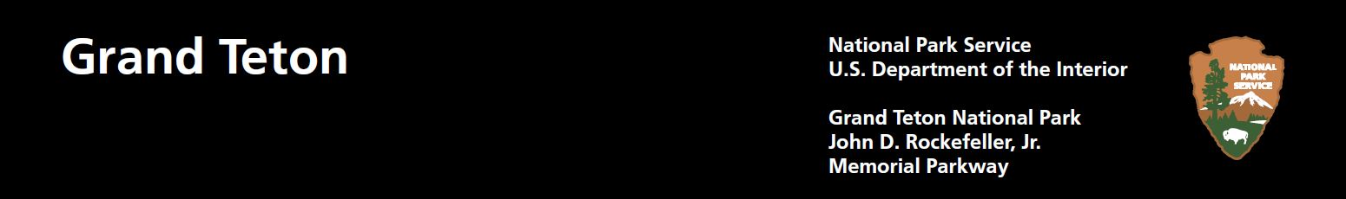

Volunteer in Grand Teton National Park!

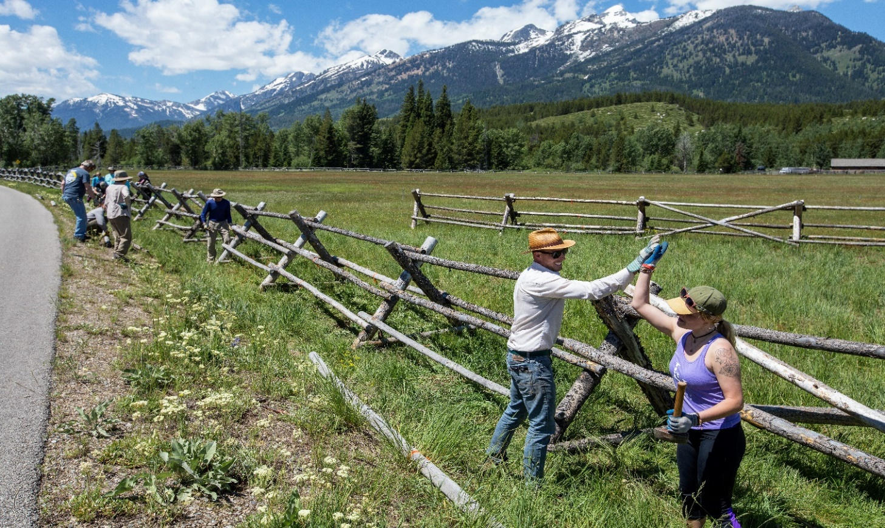
Be a part of stewardship in Grand Teton National Park! Projects vary, work involves light to moderate physical activity. All ages and skill levels are welcome. Tools and protective equipment are provided.

National Trails Day - Saturday, June 6th

Community Volunteer Days- Thursdays.

June 11th, and 25th
July 9th, 16th, 23rd and 30th
August 6th, 13th, 20th, 27th
September 10th, 17th, 24th

National Public Lands Day-Saturday, Sept 26th

Please R.S.V.P. for details.

Contact Angela Timby:
Phone: (307)453-1541

Email: angela_timby@nps.gov

